***ROLE OF WHO IN PANDEMIC***

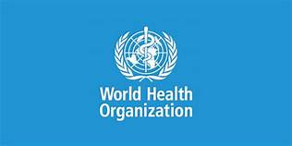

***А brief сritiсаl exаminаtiоn оf the rоle оf WHО in рrоviding glоbаl heаlth seсurity during the Соvid-19 раndemiс:***

During the pandemic, WHO continuously monitored the evolution of the pandemic, and developed guidance for Member States to put in place appropriate measures including enhanced surveillance and active monitoring, assessment of the pandemic characteristics, and recommendations on appropriate measures including medical and non-medical interventions.

WHO’s risk assessments were balanced, independent and transparent. Daily updates, weekly surveillance overviews and guidance from WHO provided the basis for evidence-based decisions by the Member States, especially those with fewer resources to perform their own risk assessments. The ECDC regularly developed and provided independent risk assessments, updated them, discussed their content with their Advisory Forum, which consists of the most credible experts in the European Union (EU) public health institutions.

There was regular interaction between risk assessors and risk managers in the EU system. During the pandemic frequent teleconferences were held with risk managers in the Member States. There was general good collaboration between WHO, EU, ECDC, the European Medicines Agency (EMA) and the European Food Safety Authority (EFSA), especially considering this was the first major health crisis since founding of WHO.